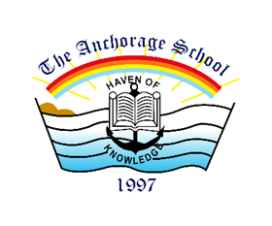

The Anchorage School
Sponsorship & Scholarship Form

Date: ______________
Sponsor Full Name: _______________________________
Name of the Student : ______________________________
Grade Level : ____________________________________
Student’s Details:

Scholarship/Sponsorship Type:
- Merit
- Need Based

Scholarship/Sponsorship Amount:
- 100% of yearly tuition = $1000
- 50% of yearly tuition for a single student = $500
- Other $____________

Sponsor’s Signature: _______________________

Would you like to see the progress of the student?
For Office Use:
Signatures: | Status:
________________  (Accounts Dept.) | (Approved/Rejected)
________________  (Vice-Principal) | (Approved/Rejected)
Scholarship (PKR)

